***GAME DESIGN DOCUMENT***

*Ice Robber*

By *Team Maverick*

Overview/Theme

## Idea Summary

The theme of the game will be based around the "baraf-paani game". Where there is a robber who enters a place that is either a jewelry store/some museum with expensive artifacts, etc. There will be security guards and cameras surrounding the expensive items. The robber can throw ice balls on the guards (to freeze them) and security cameras (to stop their functionality) for a specified time. The timer starts when the ice ball freezes the guard and camera, so the robber has a specified time to steal the jewels and escape (until the ice melts down and reactivates the cameras and guards can also catch the robber). If he fails to do so, he will be caught and sent to jail. If we throw ice ball on one security guard/camera and some other guard/camera sees us then we will also get caught, etc.

## Goal

The fact that every move in game counts and increase in difficulty level as game progresses would make it a great game. It would be addictive as it would get harder after each passing level that would urge players to do better. The simplicity and progressive difficulty would make it a great game. It would be addictive as it would get harder after each passing level that would urge players to do better.

# Mock Ups

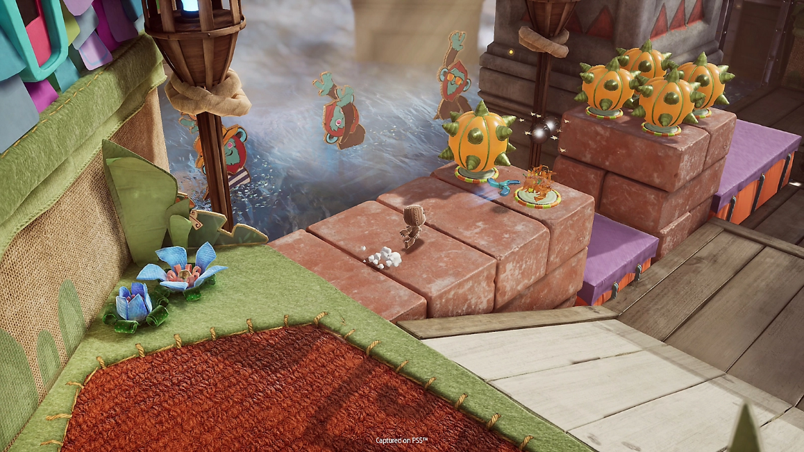

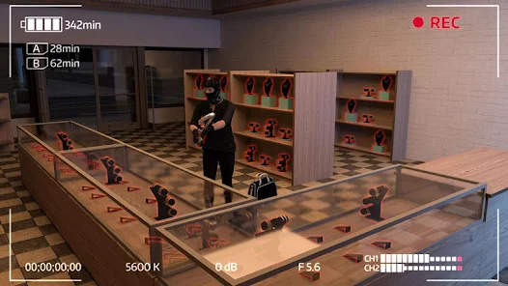

# References

* [Money Movers](https://www.crazygames.com/game/money-movers)
* [Sackboy: A Big Adventure](https://www.youtube.com/watch?v=ZOk3fj5ujNM)

# Art Style (check any number of boxes that apply)

* 2D
* 3D
* Pixel
* Cartoon
* Cell Art
* Low Poly
* High Poly
* Photo Realism
* Stylized Realism
* Isometric
* Other

## Sample images or references

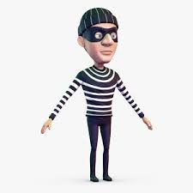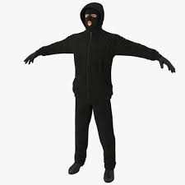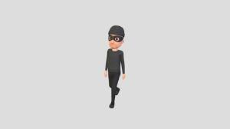

# Look & Feel / Camera

* First Person
* Third Person
* Over The Shoulder
* Top Down
* Face On
* Other (Side-View)

Third Person Camera:

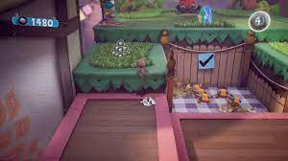

Side View/ 90o on y-axis:

# Mechanic

## **Controls**

* Portrait
* Landscape
* Single Touch
* Joystick
* Tap
* Slide
* Swipe
* Hold
* Release
* Drag
* Other

Joystick will be used for player movement whereas the tap control will be used for throwing ice balls and jumping.

## **Core Loop**

Player taps to start (selects level based on his progress)

The player will do movement with the help of joystick. He must pass through different rooms, in order to steal the jewels while being aware of the security guards, cameras, etc.

Along the way, he can throw ice balls on security guards and cameras in order to freeze their movement and functionality and have limited time to steal but should not be seen by other guards/cameras.

The level ends when After he successfully reaches and robs the main artifact/jewelry room.

# Progression

* Level Based
* Score Based
* Upgrade Based
* Star Based
* % Complete Based
* Engagement Based
* Content Based
* Other

**Briefly describe how the progression in the game works?**

The game will progress in levels, to complete a level it is necessary for object to reach the final room and stealing every expensive item along the way, after completing one level stars will be provided based on how many lives (out of 3) was the player able to retain. If the 3 lives were retained, 3 stars will be awarded, if player was caught once and had to restart than 2 stars and if player was caught 2 times 1 star would be awarded. No stars would be awarded if player fails to reach and rob the final room, this will result in not passing the level. The total number of stars would be considered as the score and for example, if in level-15, 30 stars are required to unlock it and the player has 25, it would require the player to go back to prior levels, think of the best paths and earn more stars than their previous attempts to reach 30 stars and then unlock level 15.

*Sugar Kid*

By *Team Maverick*

Overview/Theme

## Idea Summary

The game is based on the poem "Baby Baby Yes Mama" poem. Where the kid wants to eat sugar, so he must get it by dodging his mom through the maze type levels. The levels consist of rooms and each room has obstacles and angry mom trying to find/catch the kid. We can add more people (like angry father/grandmother) and animals (like dogs, etc.) which will help in increasing the difficulty level of the game as it progresses. We can also add some powers/special abilities (like; the kid can throw a bone towards the room where there is a dog, and a wool ball where there is a cat, in order to distract them) that may help the kid camouflage to get past the obstacles/enemies.

## Goal

**What's the aim of the player playing this game? Why will it be fun, entertaining or satisfying?**

The simplicity and progressive difficulty would make it a great game. It would be addictive as it would get harder after each passing level that would urge players to do better. Moreover, it would psychologically help people in increasing their reaction time and be a source of nostalgia for the people who are playing the game as it will remind them of their childhood memories (i.e., poem that they used to hear from their parents/grandparents).

# Mock Ups

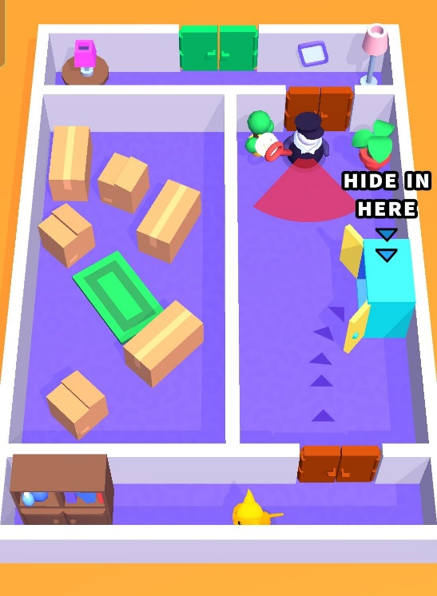

# References

* [Cat Escape](https://play.google.com/store/apps/details?id=gg.sunday.catescape&hl=en&gl=US)
* [Hide ‘N Seek](https://play.google.com/store/apps/details?id=com.seenax.HideAndSeek&hl=en&gl=US)

# Art Style (check any number of boxes that apply)

* 2D
* 3D
* Pixel
* Cartoon
* Cell Art
* Low Poly
* High Poly
* Photo Realism
* Stylized Realism
* Isometric
* Other

## Sample images or references

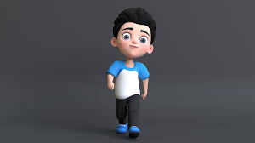

# Look & Feel / Camera

* First Person
* Third Person
* Over The Shoulder
* Top Down
* Face On
* Other

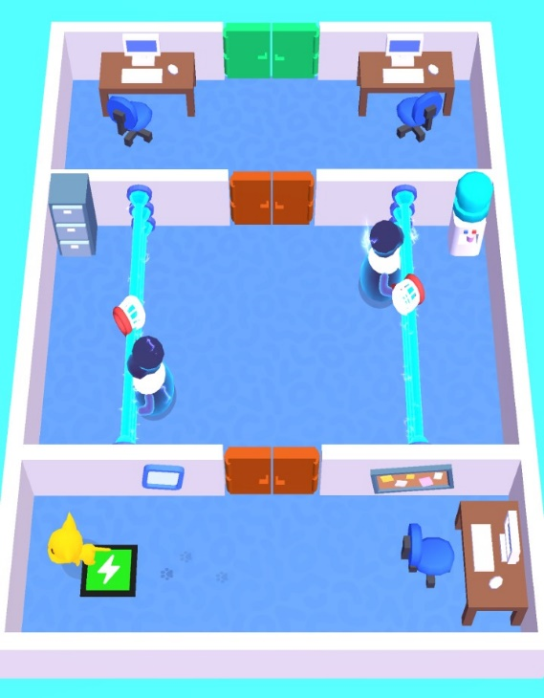

# Mechanic

## **Controls**

* Portrait
* Landscape
* Single Touch
* Joystick
* Tap
* Slide
* Swipe
* Hold
* Release
* Drag
* Other

The player movement will be controlled by dragging a invisible joystick on the bottom center of the screen and special powers gained over time can be triggered by tapping on the icon on bottom left.

## **Core Loop**

Press Play button to start…

Player drags on the bottom center of the screen to move the character

Player has to move the character through different

rooms to fetch the jar of sugar, while trying to dodge his angry mom.

In order to complete the level successfully, after finding the jar he also must exit the level through the final door.

# Progression

* Level Based
* Score Based
* Upgrade Based
* Star Based
* % Complete Based
* Engagement Based
* Content Based
* Other

**Briefly describe how the progression in the game works?**

The game will progress in levels, to complete a level it is necessary for character to collect the main sugar jar and use his bone/wool ball throwing ability to dodge aggressive enemies like cats, dogs, etc. After completing one level stars will be provided based on how many lives (out of 3) was the player able to retain. If the 3 lives were retained, 3 stars will be awarded, if player was caught once and had to restart than 2 stars and if player was caught 2 times 1 star would be awarded. No stars would be awarded if player fails to get the sugar jar, this will result in not passing the level. The total number of stars would be considered as the score and for example, if in level-15, 30 stars are required to unlock it and the player has 25, it would require the player to go back to prior levels, think of the best paths and earn more stars than their previous attempts to reach 30 stars and then unlock level 15.

*School Explorer*

By *Team Maverick*

# Overview/Theme

## Idea Summary

This idea is based on school theme, but the levels will be set like Super Mario game, we the student has to find/collect his school item of the day and clear the level. The difficulty of the levels will be based on finding more items or special items in hidden places in specific time.

## Goal

**What's the aim of the player playing this game? Why will it be fun, entertaining or satisfying?**

The simplicity and progressive difficulty would make it a great game. It would be addictive as it would get harder after each passing level (as the items will be hidden in more complex areas) that would urge players to do better. Moreover, it would psychologically help people in increasing their concentration level and time and would turn out to be a great brain exercise.

# Graphical user interface, application Description automatically generatedMock Ups

# References

* [My School Learning Game](https://play.google.com/store/apps/details?id=com.sbt_human.ptitsprofs&hl=en&gl=US)
* [That Level Again](https://play.google.com/store/apps/details?id=ru.iamtagir.game.android&hl=en&gl=US)
* [Super Mario Run](https://play.google.com/store/apps/details?id=com.nintendo.zara&hl=en&gl=US)

# Art Style (check any number of boxes that apply)

* 2D
* 3D
* Pixel
* Cartoon
* Cell Art
* Low Poly
* High Poly
* Photo Realism
* Stylized Realism
* Isometric
* Other

## Sample images or references

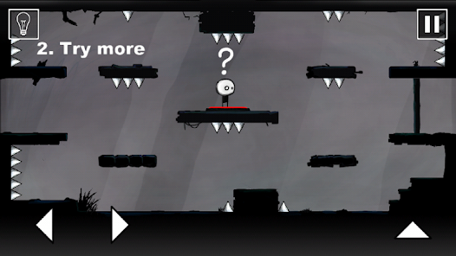

# Look & Feel / Camera

* First Person
* Third Person
* Over The Shoulder
* Top Down
* Face On
* Other

# Mechanic

## Controls

* Portrait
* Landscape
* Single Touch
* Joystick
* Tap
* Slide
* Swipe
* Hold
* Release
* Drag
* Other

Two buttons on bottom left corner will be for back/forth movement along x-axis and one tap button one right corner for jumping.

## Core Loop

Player taps to start

Player is presented with an item of the day which will be related to school. that he must find by progressing the level.

During the game, the player will encounter enemies The player can shoot them and collect coins.

Once the item of the day has been found the level ends.

# Progression

* Level Based
* Score Based
* Upgrade Based
* Star Based
* % Complete Based
* Engagement Based
* Content Based
* Other

*Class Cricket*

By *Team Maverick*

# Overview/Theme

## Idea Summary

The game is based on school theme where we used to play cricket with copies, registers, clip board, rulers (act as bat) and paper balls. We have to hit the paper balls in the dustbin using the previously mentioned objects and for the next levels we can increase the difficulty making the bat with less wide items e.g., ruler, etc.

## Goal

**What's the aim of the player playing this game? Why will it be fun, entertaining or satisfying?**

The simplicity and progressive difficulty would make it a great game. It would be addictive as it would get harder after each passing level (as the items will become less wide in size) that would urge players to do better with the reaction and accuracy. Moreover, it would psychologically help people in increasing their response/reaction time and would turn out to be a great brain exercise.

# Mock Ups

# References

* [Cricket Game](https://www.miniplay.com/game/cricket-game)

# Art Style (check any number of boxes that apply)

* 2D
* 3D
* Pixel
* Cartoon
* Cell Art
* Low Poly
* High Poly
* Photo Realism
* Stylized Realism
* Isometric
* Other

## Sample images or references

# Look & Feel / Camera

* First Person
* Third Person
* Over The Shoulder
* Top Down
* Face On
* Other

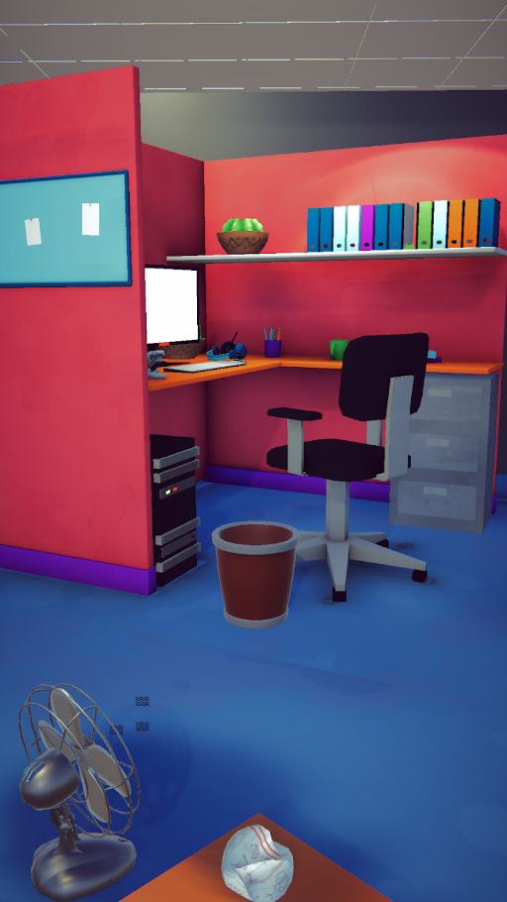

# Mechanic

## Controls

* Portrait
* Landscape
* Single Touch
* Joystick
* Tap
* Slide
* Swipe
* Hold
* Release
* Drag
* Other

Swipe towards the dust bin to hit the ball in that direction. If swipe distance is small the ball will travel short distance and if the swipe distance is greater than the ball will go much further with more speed.

## Core Loop (Feel Free to Replace the Diagram Below)

Player clicks on the PLAY button.

Player swipes on the screen in the direction of the dust bin.

As the game progresses the levels get tougher, as the objects used to hit the ball get less wide.

If the player misses a shot in the dust bin, score suffers a reduction and if ball goes in the bin, player is awarded a point. This repeats till the player reaches a target score for each level.

# Progression

* Level Based
* Score Based
* Upgrade Based
* Star Based
* % Complete Based
* Engagement Based
* Content Based
* Other